**Lesson 9 Demo 3**

**Understanding Cluster and Node Logs**

**Objective:** Understanding cluster and node logs

**Tools required:** Kubernetes platform with master, worker1, and worker2 nodes

**Prerequisites:** fluentd configuration setup

Steps to be followed:

1. Getting started with worker-node1.example.com
2. Experimenting with kubelet

**Step 1: Getting started with worker-node1.example.com**

* + 1. Go to the worker-node1.example.com

**Step 2: Experimenting with kubelet**

* + 1. Check the kubelet status using the following command:

**sudo systemctl status kubelet**

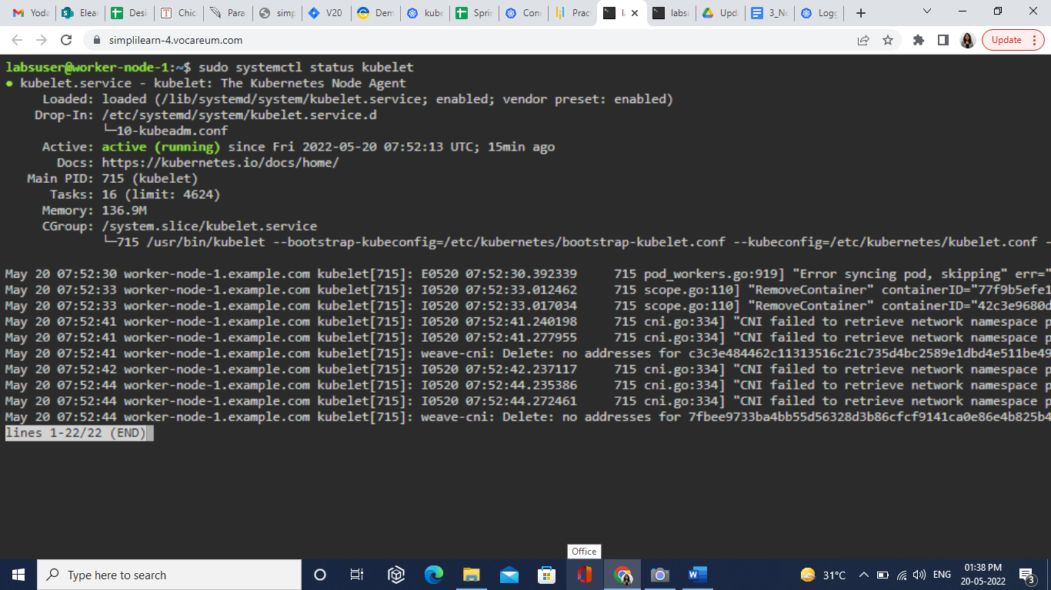

* + 1. Introduce the error in the kubeadm.conf file with the following command:

**sudo vim /etc/systemd/system/kubelet.service.d/10-kubeadm.conf**

* + 1. Reload the daemon and restart the kubelet service using the following command:

**sudo systemctl daemon-reload**

**sudo systemctl restart kubelet**

**sudo systemctl status kubelet**

**`**

* + 1. Check logs using the following command:

**sudo journalctl -xu kubelet -n**

* + 1. Go to master to check if worker-node1.example.com is ready or not using the following command:

**kubectl get nodes**

